Assignment 1
  - Deadline: Thursday 20/02/2020 @ 23:59
[Total Mark for this Assignment is 5]

Web Design
IT404

Instructions:
- You must submit two separate copies (one Word file and one PDF file) using the Assignment Template on Blackboard via the allocated folder. These files must not be in compressed format.
- It is your responsibility to check and make sure that you have uploaded both the correct files.
- Zero mark will be given if you try to bypass the SafeAssign (e.g. misspell words, remove spaces between words, hide characters, use different character sets or languages other than English or any kind of manipulation).
- Email submission will not be accepted.
- You are advised to make your work clear and well-presented. This includes filling your information on the cover page.
- You must use this template, failing which will result in zero mark.
- You MUST show all your work, and text must not be converted into an image, unless specified otherwise by the question.
- Late submission will result in ZERO mark.
- The work should be your own, copying from students or other resources will result in ZERO mark.
- Use Times New Roman font for all your answers.
Student Details:
Name: ###  CRN: 21412 |  | ID: ###

Question One
2 Marks
Learning Outcome(s):
Identify most HTML tags and CSS properties and use a text editor to construct the basic HTML and CSS structure for a webpage.

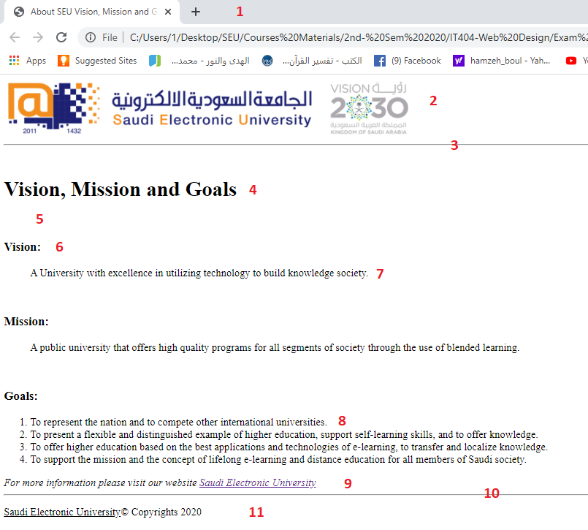
Write the source HTML document for the Webpage shown below, taking into consideration all points from 1-11:

Point | Description | Marks
1 | Title | 0.2
2 | Image (English-SEU logo) | 0.2
3 | Horizontal line | 0.1
4 | Heading | 0.2
5 | Whitespace | 0.2
6 | Heading | 0.2
7 | Blockquote | 0.2
8 | List | 0.2
9 | Address & link to SEU website | 0.2
10 | Horizontal line | 0.1
11 | Underlined & Copyright | 0.2

Answer
<!DOCTYPE HTML>
<html>
<head>
<title>About SEU Vision, Mission, and Goals</title>
</head>
<header>
<img src="SEU_logo.jpg" alt="English-SEU Logo" height="50" width="100">
</header>
<hr>
<body>
<h1>Vision, Mission, and Goals</h1>
<br>
<h4>Vision: </h4>
<blockquote>A university with excellence in utilizing technology to build knowledge society</blockquote>
<h4>Mission:</h4>
<blockquote>A public university that offers high quality programs for all segments of the society through the use of blended learning</blockquote>
<h4>Goals:</h4>
<ol>
<li>To represent the nation and to compete other international universities. </li>
<li>To represent a flexible and distinguished example of higher education, support self-learning skills, and to offer knowledge. </li>
<li>To offer high quality education based on best applications and technologies of e-learning, to transfer and localize learning. </li>
<li> To support the mission and the concept of lifelong e-learning and distance education for all members of the Saudi society. </li>
</ol>
<p>For more information please visit our website <a href = “www.seu.edu”>Saudi Electronic University</a></p>
<hr>
<p><u>Saudi Electronic University</u> &copy; Copyrights 2020</p>
</body>
</html>

Question Two
2 Marks
Learning Outcome(s):
Identify most HTML tags and CSS properties and use a text editor to construct the basic HTML and CSS structure for a webpage.

Write the necessary HTML code to display the following web page. (Note: Required tags for describing the page given as in red color font)
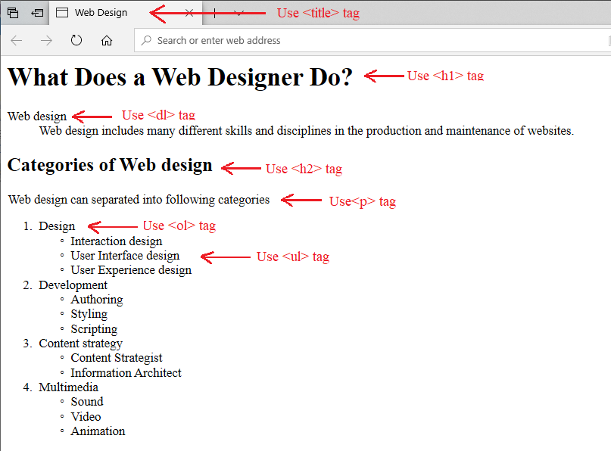
Answer
<!DOCTYPE html>
<html>
<head>
<title>Web Design</title>
</head>
<body>
<h1>What Does a Web Designer Do? </h1>
<dl>
<dt>Web Design</dt>
<dd>Web design includes many different skills and disciplines in the production and maintenance of websites. </dd>
</dl>
<h2>Categories of Web Design</h2>
<p>Web design can be divided into the following subcategories</p>
<ol>
<li>Design</li>
<ul>
<li>Interaction Design</li>
<li>User Interface Design</li>
<li>User Experience Design</li>
</ul>
<li>Development</li>
<ul>
<li>Authoring</li>
<li>Styling</li>
<li>Scripting</li>
</ul>
<li>Content Strategy</li>
<ul>
<li>Content Strategist</li>
<li>Information Architect</li>
</ul>
<li>Multimedia</li>
<ul>
<li>Sound</li>
<li>Video</li>
<li>Animation</li>
</ul>
</ol>
</body>
</html>

Question Three
1 Marks
Learning Outcome(s):
Identify most HTML tags and CSS properties and use a text editor to construct the basic HTML and CSS structure for a webpage.

Which tag is preferred to get the following output? Write the necessary HTML code to display the following web page.

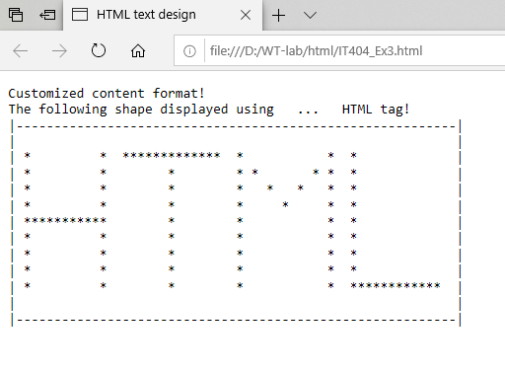
Answer
The paragraph tag is the preferred choice.
<!DOCTYPE html>
<html>
<head>
<title>Web Design</title>
</head>
<body>
<p>Customized content format</p>
<p>The following shape is displayed using the paragraph html tag</p><br>

<p>|---------------------------------------------------------------|</p>
<p>| |</p>
<p>| * * ************** * * * |</p>
<p>| * * * * * * * * |</p>
<p>| * * * * * * * * |</p>
<p>| * * * * * * * * |</p>
<p>| ************ * * * * * |</p>
<p>| * * * * * * |</p>
<p>| * * * * * * |</p>
<p>| * * * * * * |</p>
<p>| * * * * * ********** |</p>
<p>| |</p>
<p>|---------------------------------------------------------------|</p>
</body>
</html>

